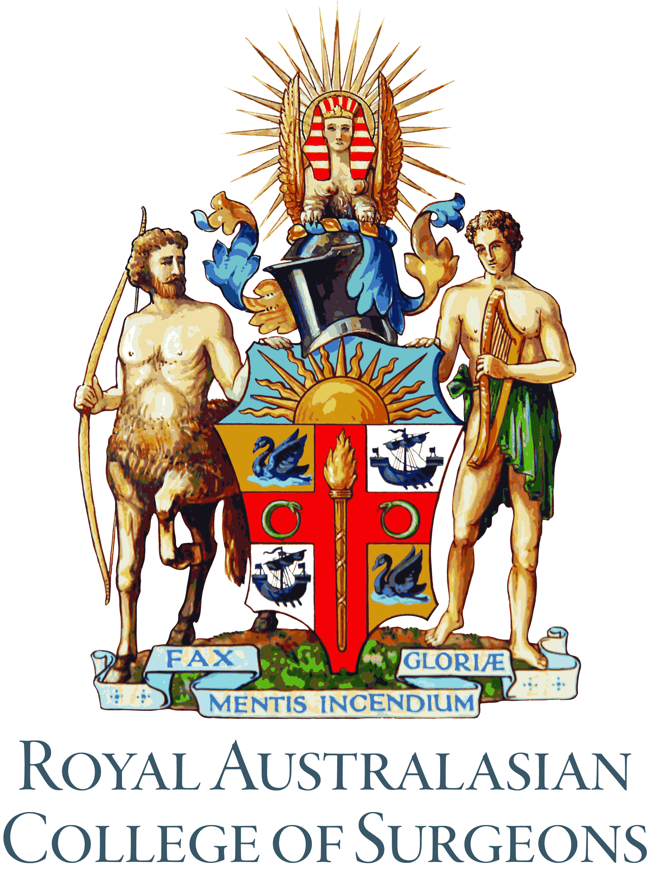

Board of Vascular Surgery
Accreditation of Surgical Education and Training (SET) Post

Hospital

Number of Posts
And
SET level (SET 1 or SET 2+)

Contact details of

Surgical Supervisor

Head of Unit

Members of Unit

Current Trainees and SET level

Be as accurate as possible. Any aspect may be checked during the course of a Hospital Post inspection.

Place a tick in either column to indicate your understanding of your hospital’s state of compliance with each criterion statement. Where a tick is placed in the “No” column, provide an explanation under Comments. Where there is uncertainty or the criterion is not completely fulfilled, it is best to write ‘Part’ in the Yes column, and provide an explanation under Comments. The Board of Vascular Surgery reserves the right to request supporting documentation of the required criteria at any time.

A schedule (or sample schedule) of each Trainee’s clinical day-to-day program, as well as a separate schedule of Unit and interdisciplinary educational meetings must accompany this application.

Standard One – Building and maintaining a Culture of Respect for patients and staff.

A hospital involved in surgical training must demonstrate and promote a culture of respect that improves patient safety.

Criteria | Yes |  |  | No
The hospital has expressed standards about building respect and ensuring patient safety.
Hospital provides a safe training environment free of discrimination, bullying, and sexual harassment.
Hospital has policies and procedures, including training for staff that promotes a culture and environment of respect and professionalism.
Hospital has clearly defined policy detailing how to make a complaint, options, investigation process and possible outcomes which includes a process to protect complainants.
Place a tick against the following document types cited.
- Code of Conduct
- Bullying/ Harassment Policy
- Complaint Management Policy/Procedure (patient)
- Grievance Management Policy/Procedure (staff)
- Speaking up for Patient Safety program – Promoting Professional Accountability
- Incident Management System
- Other – please specify

Comments

Standard Two – Education facilities and systems required

All Trainees must have access to appropriate educational facilities & systems required to undertake training

Criteria | Yes |  |  | No
Private areas isolated from clinical activity are available to the trainee for self-education and tutorials.
Tutorial room available when required.
Designated study area/room available isolated from busy clinical areas.
Comments

Standard Three – Quality of education, training and learning

Trainees have opportunities to participate in a range of desirable activities, the focus of which is inclusive of their educational requirements.

Criteria | Yes |  |  | No
The trainee is provided at least one hospital based Vascular tutorial on a fortnightly or monthly basis. Please attach a schedule of the Trainee’s clinical day-to-day program, as well as a schedule of Unit and interdisciplinary educational meetings.

For part-time training please attach evidence that trainee will be involved in pro rata experience in outpatient clinics, on call roster, operating, and angiography lists and inpatient care.
The trainee has access to skills training equipment within the hospital network.
The trainee is able to attend a regular program of in hospital multi-disciplinary educational meetings.
Trainees have access to external educational activities and are given educational leave to attend obligatory face-to-face RACS/Specialty courses. There are also opportunities for research, inquiry and scholarly activity.

Comments

Standard Four – Surgical Supervisors and staff

Program managed by appropriate and accessible supervisor supported by the institution and committed surgeons, delivering regular training and feedback

Criteria |  |  | Yes |  |  | No
To assist supervisors in their roles in educating and assessing trainees, RACS has developed Standards for Supervision. The standards define education practice for supervisors and outline the attributes, roles and responsibilities and effective teaching methods for supervisors. Please indicate that you have read and are compliant with the RACS Standards for Supervision.

The hospital employs two or more Vascular surgeons with appropriate College recognised qualification (FRACS in Australasia or are certified as equivalent) actively involved in trainee education.
Supervisors and Trainers who are ANZSVS members must participate in an ANZSVS endorsed audit and certificates of participation are included in this application.
The supervisor of Vascular surgical training is appropriately resourced by the hospital to be fulfilling that role and is accessible to the trainee. The supervisor must also have completed SAT SET, KTOT, Foundation Skills for Surgical Educators, and the Operating with Respect course.

All Surgeons in the unit are considered Trainers. The Trainees will have exposure to working with all Surgeons in the unit and this is demonstrated in the included unit operating timetable.
In-training assessments are completed within the required timeframe, with the trainee in attendance, and each report reflects department consensus.

Comments

Standard Five – Support services for trainees

Hospitals and their networks are committed to the training, learning and wellbeing of trainees who in turn acknowledge their professional responsibilities.

Criteria |  |  | Yes |  |  | No
Trainee rosters comply with safe work practices and call are consistent with the RACS standards for safe working hours. The Board of Vascular Surgery considers 1:3 to be an appropriate on-call arrangement. Please attach a copy of a typical on-call roster.

Rosters and work schedules in Australia take into account the principles outlined in the AMA National code of Practice, Hours of Work, Shift Work, and Rostering for Hospital Doctors and in New Zealand the principles outlined in the Multi Employer Collective Agreement (MECA).

The trainee has ready access to human resources services including counselling if required. The hospital network promotes trainee safety, and provides security for trainees, where necessary.

Hospital has a flexible employment policy allowing for part-time and job sharing options with a clearly identified process for applying for these arrangements.
For part-time training posts the hospital is committed to providing adequate hand over process and sufficient cover from other or extra medical staff.

Comments

Standard Six – Clinical load and theatre sessions

Trainees must have access to a range and volume of clinical and operative experience which will enable them to acquire the competencies required to be a surgeon.

Criteria |  | Yes |  |  | No
The trainee is provided with access to a supervised outpatient clinic with sufficient mix of new and follow-up patients. At least one consultant should be present and ideally two consulting rooms should be available.

The trainee will be involved in at least 100 major* Vascular procedures per year.
A part-time trainee will be involved in at least 50 major* Vascular procedures per year.

*as defined in the Vascular Surgery in-training assessment

Evidence that the trainee attends at least 3 supervised inpatient operating lists (or 14 hrs) per week.
A part-time trainee attends at least 3 supervised inpatient operating lists (or 14 hrs) per fortnight.

Trainees have priority access, as first surgeon, to all cases necessary to further their training.

Trainees have access to active involvement in Endovascular Surgery.

Trainees have access to active involvement in Ultrasound Examination.

Comments

Standard Seven – Equipment and clinical support services

A hospital must have the facilities, equipment and clinical support services required to manage surgical cases in Vascular Surgery.

Criteria |  | Yes |  |  | No
The hospital has appropriate accreditation and a copy of the relevant accreditation certificate has been provided.
The hospital has resources essential to provide safe services at appropriate complexity.
The hospital monitors radiation exposure and provides dosimeters to trainees. A copy of the relevant current Radiation Safety Certificate has been included. Radiation User licenses for all members of the unit must also be included.

The hospital provides facilities and services for:
Carrying out diagnostic and therapeutic surgical procedures
Imaging – diagnostic and intervention services. The hospital should have appropriate imaging facilities to gain experience in both endovascular techniques and vascular ultrasound on or off site.

Accident and Emergency
Intensive Care Unit
Secretarial support for the department
Comments:

Standard Eight – Clinical Governance quality and safety

A hospital involved in surgical training must be fully accredited and have the governance structure to deliver and monitor safe surgical practice.

Criteria |  | Yes |  |  | No
The hospital has an appropriate governance structure. There is a designated head of unit with negotiated role in governance and leadership.
The hospital has a surgical audit and peer review program, which as a minimum complies with the RACS Guidelines for Effective Morbidity and Mortality Meetings Bronze level.
The hospital has a systems review in place and evidence of active audit program.
Comments:

Appendix

Please list below any services or training opportunities not referred to in the above document that are believed to enhance the training experience of your institution.

